**MONITORING INCIDENT STATES FOR EFFECTIVE MANAGEMENT**

**TEAM MEMBERS:**

SRI HARIHARAN M (team leader)

GOPAL LOHAR

KARUPPAYI C

GOWTHAM K

**USER STORY:**

As a Service Now Assignment Group Manager,

I want a report that provides visibility into incidents assigned to my group, filtered by their current state (New, On Hold, In Progress),

so that I can efficiently track, manage, and prioritize the incidents handled by my team.

**SKILLS:**

Knowledge on Service now administration

Knowledge on tables

Knowledge on reports

**OBJECTIVES:**

The project "Monitoring Incident States for Effective Management" aims to develop a system for tracking and managing incidents from detection to resolution. It focuses on improving response times, enhancing team collaboration, automating incident tracking, and ensuring accurate documentation. The project also prioritizes high-impact incidents, refines management processes using performance metrics, ensures compliance, and integrates with existing systems to optimize incident resolution and drive continuous improvement.

**IMPLEMENTATION**

**ACTIVITY-1:**

1. Open service now developer Instance
2. Click on All
3. Search for reports and click on create new

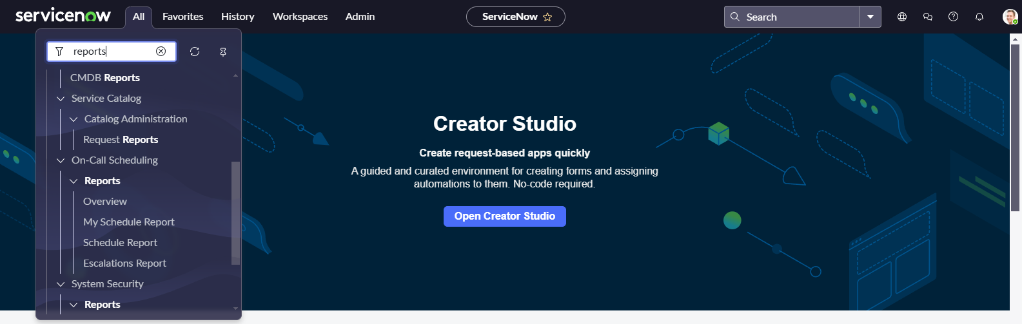

1. Give the report name
2. Select source type as table
3. Select table incident

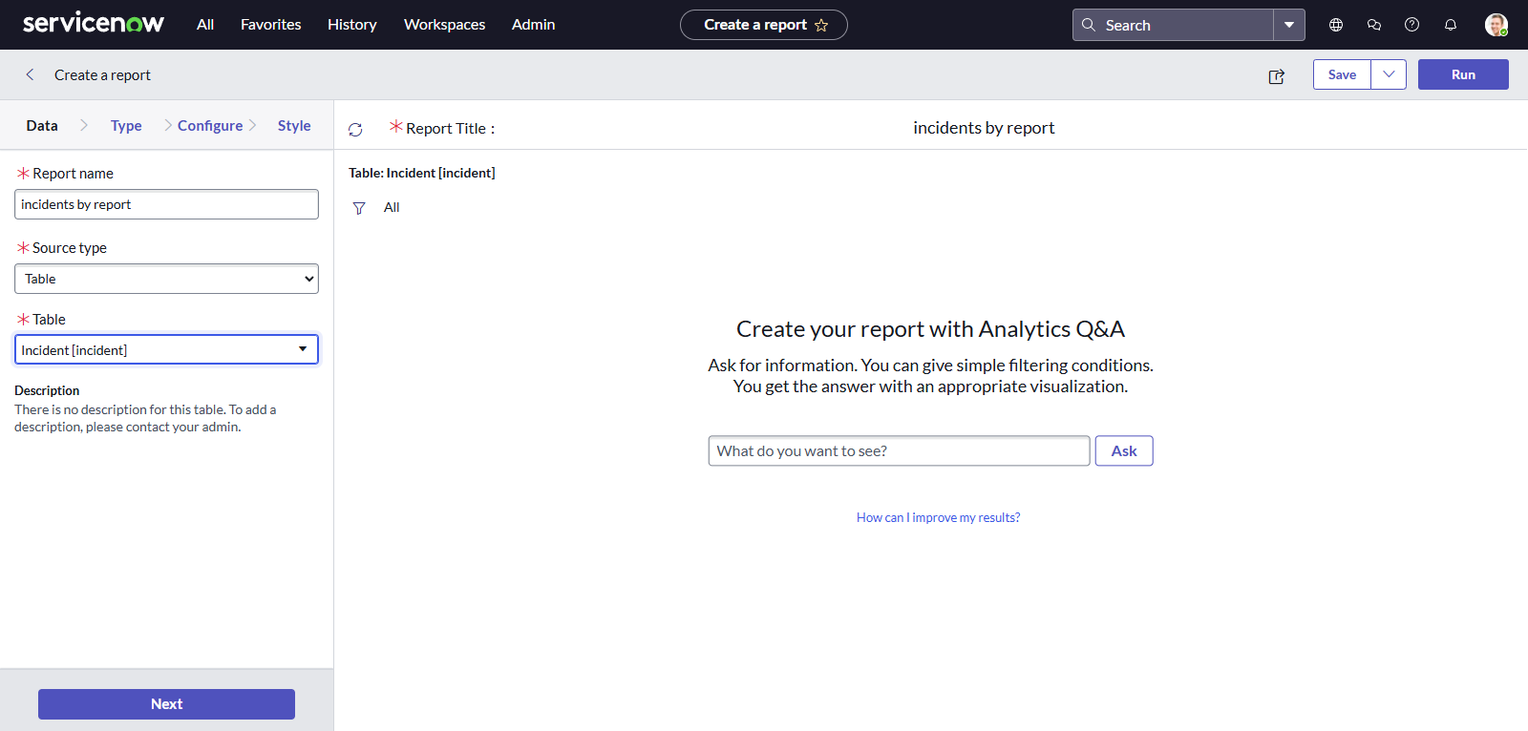

1. Click on next
2. Select type as pie chart
3. Click on funnel icon and give condition  
   Field: state  
   Operator is one of  
   Value : new, on hold , in progress

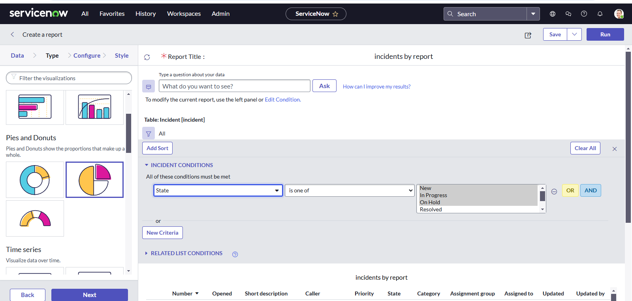

1. Click on next
2. Group by assignment group and click on next

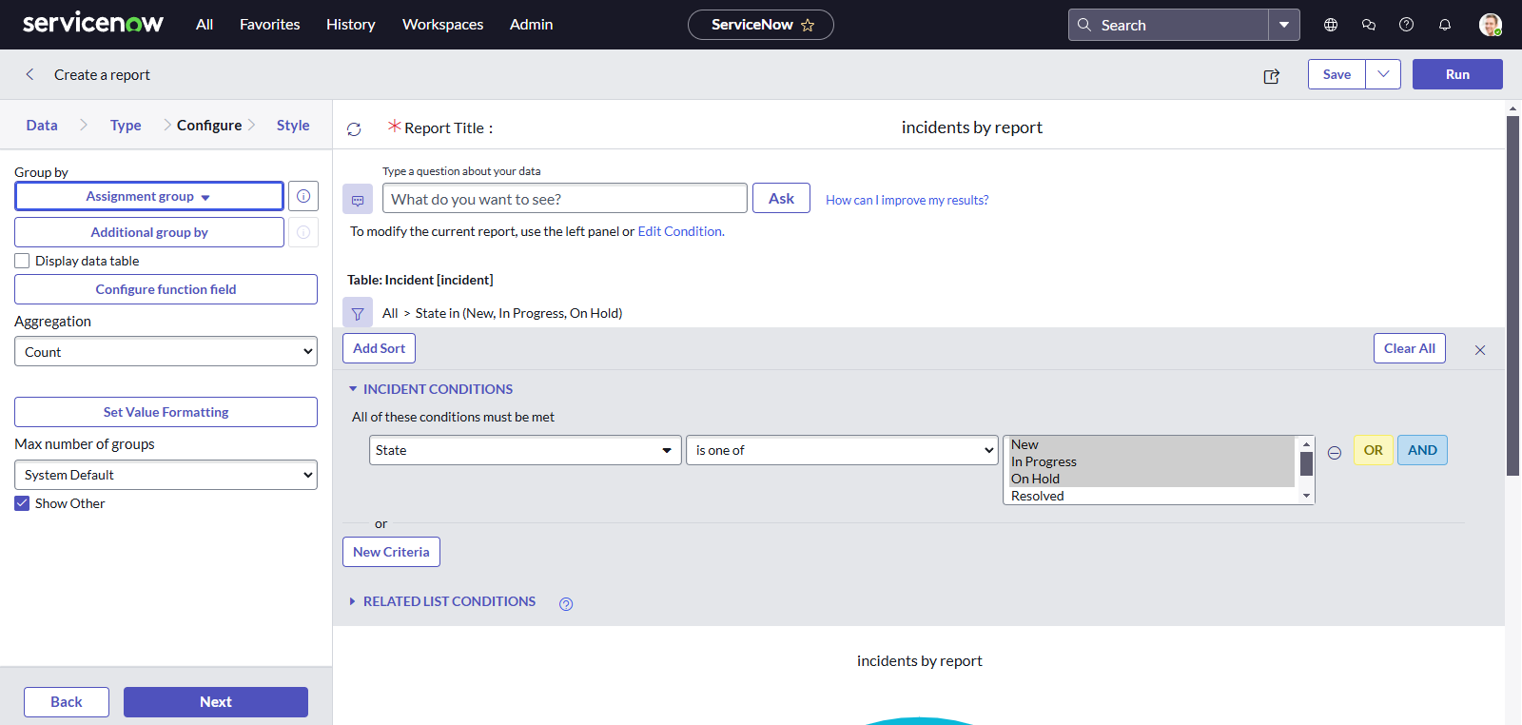

1. Click on save
2. Click on run

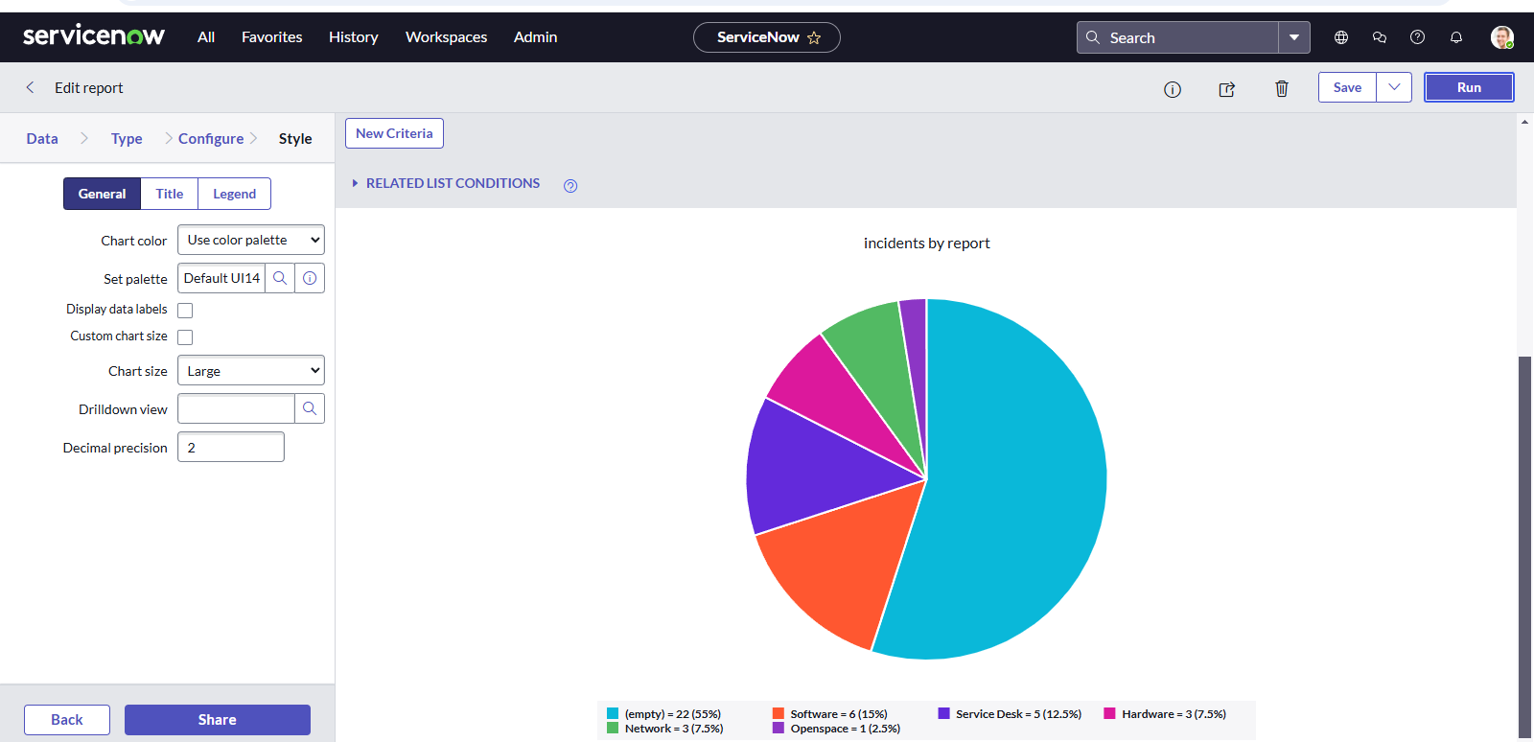

* 1. Now add report to dashboard

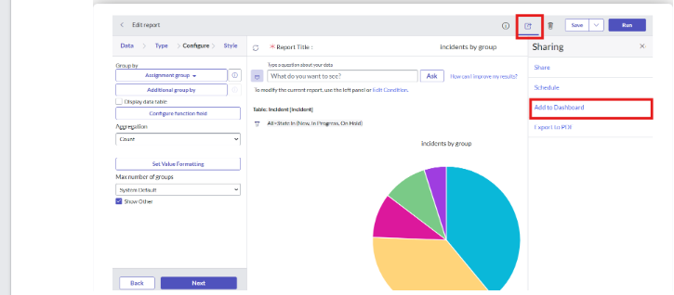

1. Give the dashboard and title name

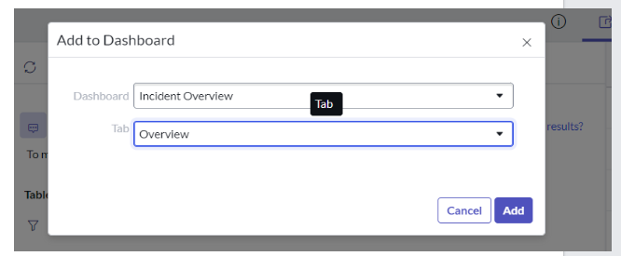

**RESULT**

1. Open service now PDI instance
2. Click on all
3. Search for dashboard
4. Select dashboard under self service

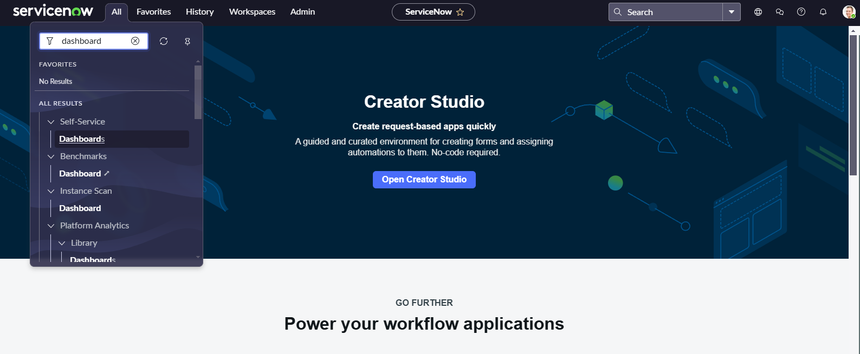

1. In the search bar enter incident
2. Select incident overview

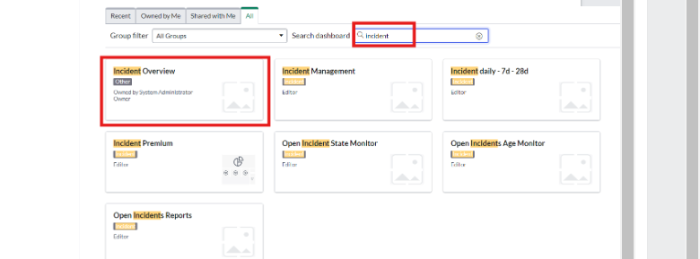

Here we can access the dashboard we create

